**NYC Traffic Motor Collisions vs. Weather Conditions**

By:

Team 3: [Ibrahim Abdulrahmon](https://github.com/abdulib),

[Chris Hart](https://github.com/zebuite),,

[Ugochi Akaluso](https://github.com/ugochi)

[Hunter Cash](https://github.com/huntercash)

**Overview:**

In the United States, there are approximately 40,000 people killed by traffic collisions and hundreds of thousands more injured every year. In an effort to eliminate traffic related deaths and severe injuries, the Vision Zero Network created the Vision Zero plan, which aims to increase “safe, healthy equitable mobility for all” by discovering trends in motor vehicle traffic collisions. Through data explorations, cities can enact and enable infrastructure, road systems, and policies that can prevent and lessen the number of severity of crashes.

**Problem:**

Our goal is to determine if there are any other contributing factors to the number of traffic collision in NYC. We will explore the weather conditions in NYC and establish a relationship between the weather conditions and motor vehicle traffic collisions in NYC by examining collision occurrences and trends throughout the year as the seasons and weather changes to answer the question: Do the weather conditions have an effect on motor traffic collision in NYC? Our null hypothesis is *There is no statistical significance between the weather and the amount of collisions, and collision related injuries.*

**DO WEATHER CONDITIONS HAVE AN EFFECT ON MOTOR TRAFFIC COLLISIONS IN NYC**?

**Which type of weather has the highest occurrence of collisions?**

Partly cloudy days and nights had the highest occurrence of collisions out of all weather detail types

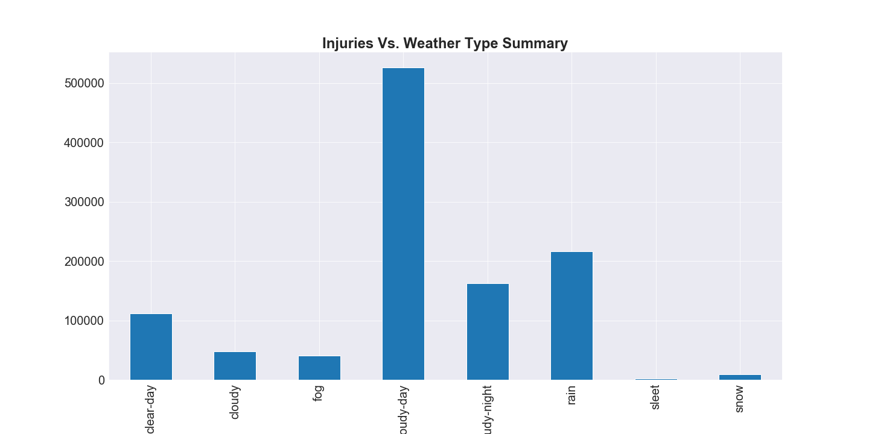

FIGURE 1: INJURIES VS WEATHER DETAIL SUMMARY

**Does the cloudiness have a significant effect on the number of Collisions or Injuries?**

There is no statistical significance or correlation between cloudiness and the amount of collisions or injuries in NYC and can accept the null hypothesis. Cloud coverage or cloudiness shows a low r squared value that explains 3% of the variability in both injuries and collisions with an increase in the standard deviation for collisions.

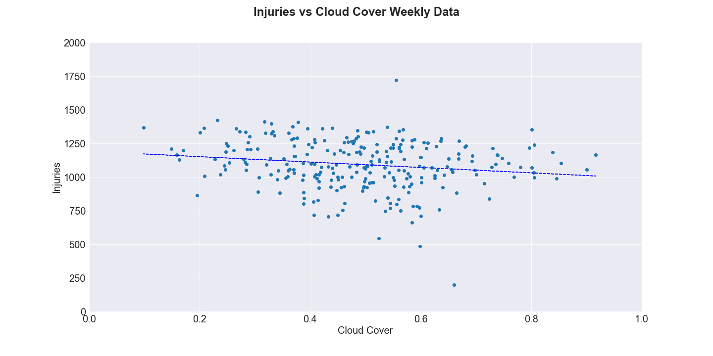



FIGURE 2: INJURIES VS WEEKLY CLOUD COVER PLOT AND STATISCAL DATA

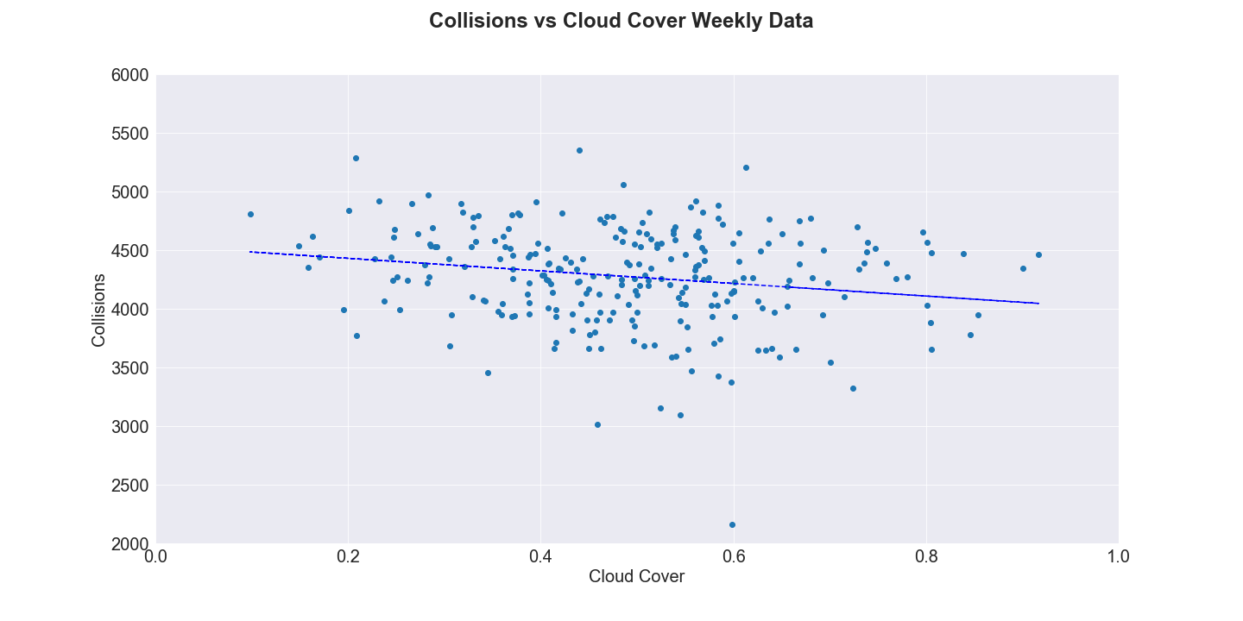



FIGURE 3: COLLISIONS VS WEEKLY CLOUD COVER PLOT AND STATISCAL DATA

**Does the minimum temperature have a significant effect on the number of Collisions or Injuries?**

There is statistical significance and correlation between the temperature in NYC and the amount of collisions or injuries. Temperature shows a r squared value that explains 35% of the variability in both injuries and collisions, low standard deviation, and a significantly low p value so we are able to reject the null hypothesis on the basis of temperature.

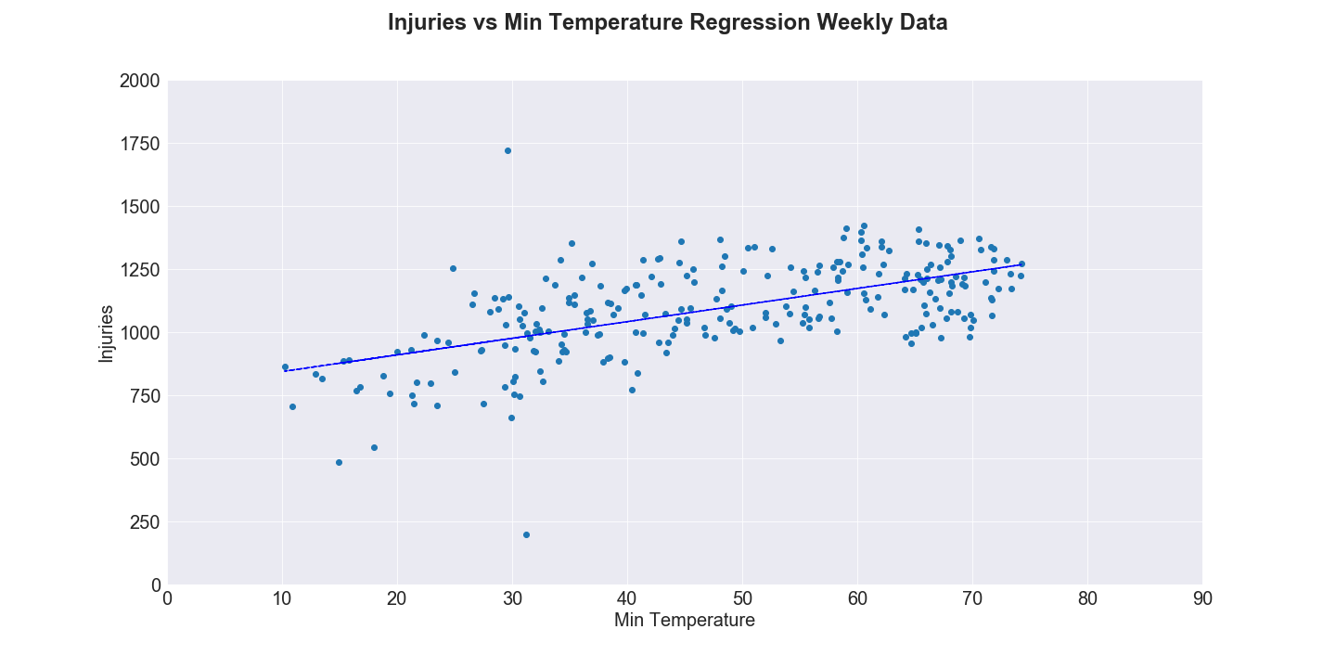



FIGURE 4: INJURIES VS AVG MINIMUM TEMPERATURE COVER PLOT AND STATISCAL DATA

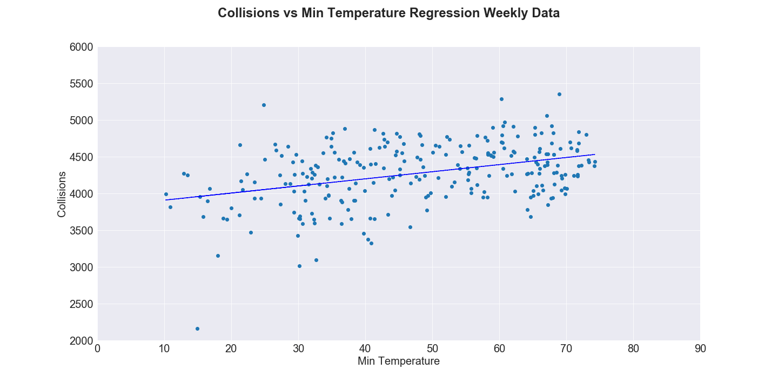



FIGURE 5: COLLISIONS VS AVG MINIMUM TEMPERATURE COVER PLOT AND STATISCAL DATA